Stress Calming Technique
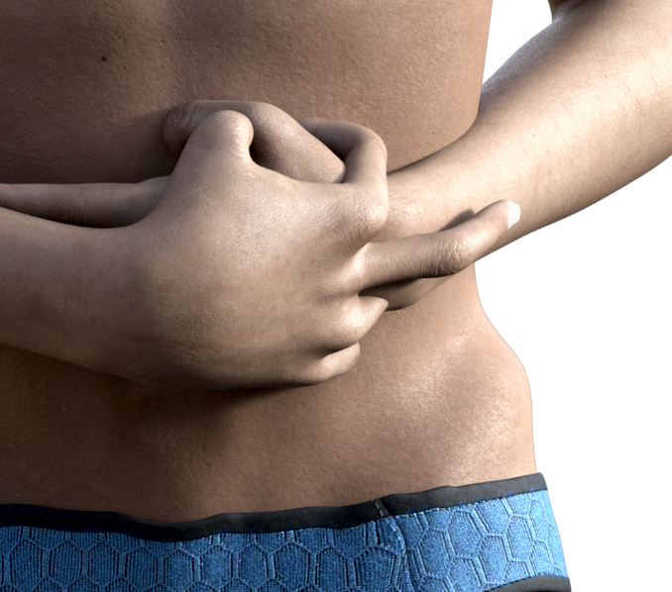
Step 1: Place the right hand over the left hand, interlocking the web of the thumbs. The right ring finger and index finger will flank the left wrist while the middle finger will run up the dorsal aspect of the distal forearm. Next, place both hands over the umbilicus. Hold your hands in this posture until exercise is over. Look in the center of your being, usually your heart charka, which is the center of the body. It will be the spark of life. Be sure this energy is from you; you do not want to use anyone else’s energy. You take that spark and with every inhalation, you build it bigger, whiter, hotter, and denser until it gets to the size of a tennis ball.
Step 2: Start this ball of white light spinning in a clockwise direction. Then let it spin in all directions. With every breath, it will increase in size getting whiter, hotter, denser, and spin faster. It will also start to conform to the body as it spins until it appears as a second skin, but just below the skin surface. Once that has occurred take a big breath in take the light and pop it out of the physical body about 6”. Then exhale, on the next inhalation suck in the light, just below the skin surface.
Step 3: Next picture a pool in front of you that has the appearance of clear liquid Diamond. You can breathe and see though this covering no need to worry. Dive into this pool so that the liquid diamond covers the entire body including the hair, between the toes and finger spaces leaving absolutely no air pockets or spaces that are not covered. Following this, step out of the pool and the liquid diamond will dry instantly. It is now a free-flowing solid diamond covering. Taking the white-hot energy, you built up. With every Inhale push against the flexible diamond coating making the energy Whiter, Hotter, Denser and denser until it is as dense as a diamond or harder, this will make the diamond coating extremely taught so that it is paper thin and very tight. It will be similar to a balloon that has maximum air in it before it pops. Now jump back into the pool and repeat the dipping process. Climb out and it will be dry and the energy and both coatings are completely flexible.
Step 4: Now picture another pool of soft liquid pink foam. You can breathe and see though this covering no need to worry. Now dive into it and be sure there are no air bubbles over the flexible diamond coating. Climb out of the pool and the pink foam will expand 6-8 inches and be completely flexible and dry. This pink foam is for absorbing minimal negative energy. In extreme negativity, the energy will pass through the pink foam hitting the flexible diamond covering. The diamond covering will return this energy multiplied 100 times, and the pink foam will convert this energy into pure love as it is reflected back.
This Technique is for Honorable use only. It could turn on you if used in any dishonorable way!

Date Developed: 1965

Developed by:

Victor L. Frank, D.C., N.M.D., D.D.

Updated: 2003

By:

Randall J. Frank, N.M.D, C.T.N., D.M., D.D.; Victor L. Frank, D.C., N.M.D., D.D.

